实验 软件架构

一、实验目的
1熟悉前后端分离下的软件架构。
2实现前后端通信
3实现后端与数据库通信
4完成前后端分离实验《Todos》

二、实验装置
IDE: VS Code
后端（Java）: jdk8，jre8
后端（node）：node，Npm
数据库：MySQL，navicat
前端：Yarn

三、实验内容
1. MVC架构
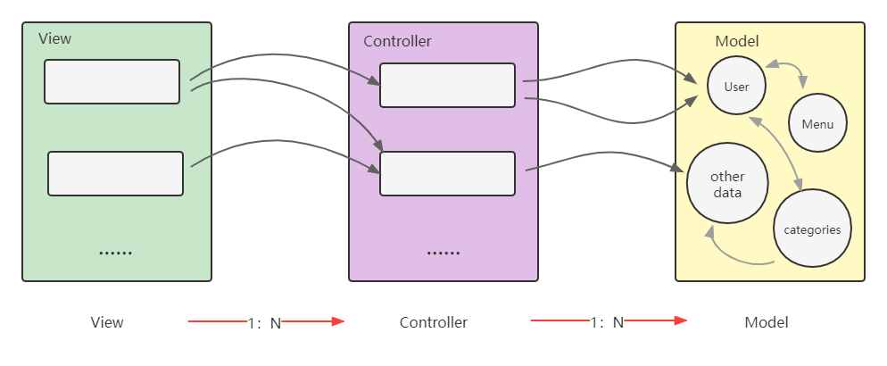

2. 系统流程
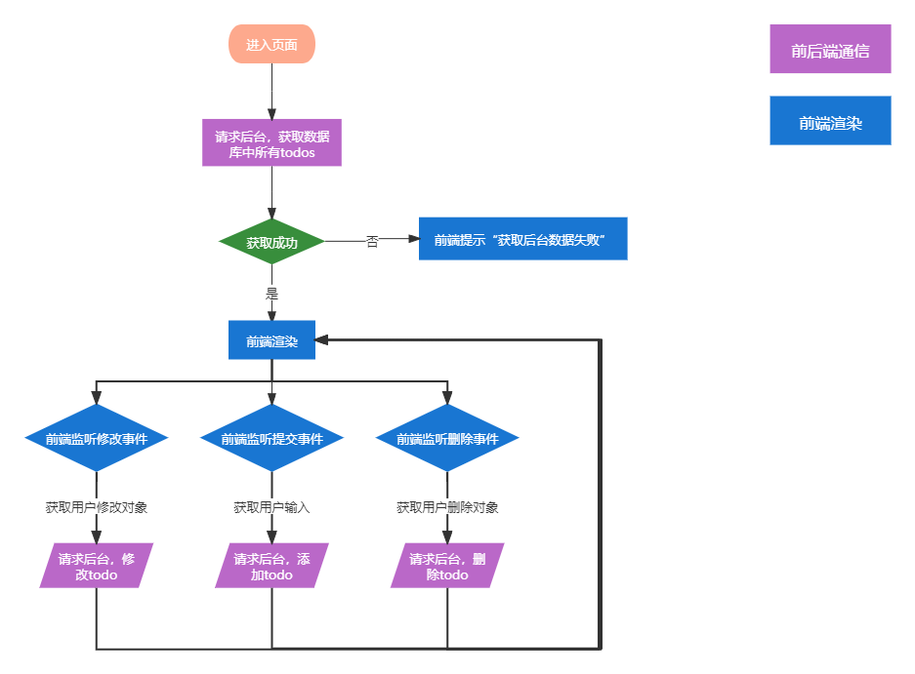

3. 后端连接数据库
3.1配置文件
进入be-spring/src/main/resources，创建application.properties
spring.jpa.hibernate.ddl-auto=update
spring.datasource.url=jdbc:mysql://${MYSQL_HOST:localhost}:3306/todos
spring.datasource.username=root
spring.datasource.password=root
spring.datasource.driver-class-name =com.mysql.jdbc.Driver

3.2 定义数据访问层Data Access Object
package com.example.accessingdatamysql;

import org.springframework.boot.SpringApplication;
import org.springframework.boot.autoconfigure.SpringBootApplication;

@SpringBootApplication
public class AccessingDataMysqlApplication {
public static void main(String[] args) {
SpringApplication.run(AccessingDataMysqlApplication.class, args);
}
}

3.3定义数据模型Model
进入be-spring/src/main/java/com/example/accessingdatamysql/model，创建TodoList.java
package com.example.accessingdatamysql;

import javax.persistence.Entity;
import javax.persistence.GeneratedValue;
import javax.persistence.GenerationType;
import javax.persistence.Id;

@Entity // This tells Hibernate to make a table out of this class
public class TodoList {
@Id
// @GeneratedValue(strategy=GenerationType.AUTO)
private String id;

private String text;

private Integer finished;

public String getId() {
return id;
}

public void setId(String id) {
this.id = id;
}

public String getText() {
return text;
}

public void setText(String text) {
this.text = text;
}

public Integer getFinished() {
return finished;
}

public void setFinished(Integer finished) {
this.finished = finished;
}
}

4. 后端操作数据库
4.1查询数据库中所有todos
public @ResponseBody Iterable<TodoList> getAllTodos() {
// This returns a JSON or XML with the todos
return todoListRepository.findAll();
}

4.2往数据库里增加一条todo
public @ResponseBody String addNewTodo (@RequestBody String todo) {
Map<String, Object> todoObj = JSON.parseObject(todo, Map.class);
Map<String, Object> todoMap = JSON.parseObject(todoObj.get("data").toString(), Map.class);
TodoList newTodo = new TodoList();
newTodo.setId(todoMap.get("id").toString());
newTodo.setText(todoMap.get("text").toString());
newTodo.setFinished(0);
todoListRepository.save(newTodo);
return "Saved";
}

4.3修改数据库中todo的finish状态
public @ResponseBody String fininshTodo (@RequestBody String todo) {
Map<String, Object> todoObj = JSON.parseObject(todo, Map.class);
Map<String, Object> todoMap = JSON.parseObject(todoObj.get("data").toString(), Map.class);
TodoList newTodo = todoListRepository.findById(todoMap.get("id").toString()).get();
newTodo.setFinished("true".equals(todoMap.get("finished").toString()) ? 1 : 0);
todoListRepository.save(newTodo);
return "Saved";
}

4.4根据id删除数据库中的一条todo
public @ResponseBody String deleteTodo (@RequestBody String todo) {
Map<String, Object> todoObj = JSON.parseObject(todo, Map.class);
Map<String, Object> todoMap = JSON.parseObject(todoObj.get("data").toString(), Map.class);
todoListRepository.deleteById(todoMap.get("id").toString());
return todoMap.get("id").toString();
}

4.5 修改为rest风格
@RequestMapping(path="/api")
@GetMapping(path="/getTodos")
@PostMapping(path="/addTodo", produces="application/json;charset=UTF-8")
@PostMapping(path="/finishTodo", produces="application/json;charset=UTF-8")
@PostMapping(path="/delTodo", produces="application/json;charset=UTF-8")

4.6 完整的Controller
package com.example.accessingdatamysql;

import org.springframework.beans.factory.annotation.Autowired;
import org.springframework.stereotype.Controller;
import org.springframework.web.bind.annotation.GetMapping;
import org.springframework.web.bind.annotation.PostMapping;
import org.springframework.web.bind.annotation.DeleteMapping;
import org.springframework.web.bind.annotation.RequestMapping;
import org.springframework.web.bind.annotation.RequestParam;
import org.springframework.web.bind.annotation.ResponseBody;
import org.springframework.web.bind.annotation.RequestBody;
import com.alibaba.fastjson.JSON;
import java.util.Map;

@Controller // This means that this class is a Controller
@RequestMapping(path="/api") // This means URL's start with /api (after Application path)
public class MainController {
@Autowired // This means to get the bean called todoListRepository Which is auto-generated by Spring, we will use it to handle the data
private TodoListRepository todoListRepository;

@GetMapping(path="/getTodos")
public @ResponseBody Iterable<TodoList> getAllTodos() {
// This returns a JSON or XML with the todos
return todoListRepository.findAll();
}

@PostMapping(path="/addTodo", produces="application/json;charset=UTF-8") // Map ONLY POST Requests
public @ResponseBody String addNewTodo (@RequestBody String todo) {
Map<String, Object> todoObj = JSON.parseObject(todo, Map.class);
Map<String, Object> todoMap = JSON.parseObject(todoObj.get("data").toString(), Map.class);
TodoList newTodo = new TodoList();
newTodo.setId(todoMap.get("id").toString());
newTodo.setText(todoMap.get("text").toString());
newTodo.setFinished(0);
todoListRepository.save(newTodo);
return "Saved";
}

@PostMapping(path="/finishTodo", produces="application/json;charset=UTF-8")
public @ResponseBody String fininshTodo (@RequestBody String todo) {
Map<String, Object> todoObj = JSON.parseObject(todo, Map.class);
Map<String, Object> todoMap = JSON.parseObject(todoObj.get("data").toString(), Map.class);
TodoList newTodo = todoListRepository.findById(todoMap.get("id").toString()).get();
newTodo.setFinished("true".equals(todoMap.get("finished").toString()) ? 1 : 0);
todoListRepository.save(newTodo);
return "Saved";
}

@PostMapping(path="/delTodo", produces="application/json;charset=UTF-8")
public @ResponseBody String deleteTodo (@RequestBody String todo) {
Map<String, Object> todoObj = JSON.parseObject(todo, Map.class);
Map<String, Object> todoMap = JSON.parseObject(todoObj.get("data").toString(), Map.class);
todoListRepository.deleteById(todoMap.get("id").toString());
return todoMap.get("id").toString();
}
}

5 前端与后端通信
5.1 发起添加一条todo的请求
// post to backend
axios.post(`/${useApi}/addTodo`, {
headers: {'Content-Type': 'application/json'},
data: JSON.stringify(todoObj)
}).then((res) => {

// request from backend
if (res.status === 200) {
// update localStorage & page
setLocalTodos(
[
...localTodos,
todoObj
]
)
} else {
throw new Error(res)
}
}).catch((err) => {
throw new Error(err)
})

5.2 发起修改一条todo的finish状态的请求
// post to backend
axios.post(`/${useApi}/finishTodo`, {
headers: {'Content-Type': 'application/json'},
data: JSON.stringify(todoObj)
}).then((res) => {

// request from backend
if (res.status === 200) {
// update localStorage & page
setLocalTodos(localTodos.map(localItem => {
if (localItem.id === todoItem.id) localItem.finished = !localItem.finished
return localItem
}))
} else {
throw new Error(res)
}
}).catch((err) => {
throw new Error(err)
})

5.3 发起删除一条todo的请求
axios.post(`/${useApi}/delTodo`, {
headers: {'Content-Type': 'application/json'},
data: JSON.stringify(todoObj)
}).then((res) => {

// request from backend
if (res.status === 200) {
// update localStorage & page
setLocalTodos(localTodos.filter(item => item.id !== id))
} else {
throw new Error(res)
}
}).catch((err) => {
throw new Error(err)
})

5.4 完整的前端
import { useState, useRef, useEffect } from 'react';
import axios from 'axios';
import './App.css';

// set 'api1' for egg.js || set 'api2' for spring boot
const useApi = 'api2'

function App() {
const input = useRef()
const [localTodos, setLocalTodos] = useState(localStorage.getItem('todos') ? JSON.parse(localStorage.getItem('todos')) : []) // null -> []
const [clickFreeze, setClickFreeze] = useState(false)

// component did mount
useEffect(()=>{
axios.get(`/${useApi}/getTodos`).then((res) => {
const data = res.data
console.log(`data from ${useApi}`, data)
setLocalTodos(data)
}).catch((err) => {
console.log(err)
window.alert('获取后台数据失败')
})
}, [])

// state update
useEffect(() => {
localStorage.setItem('todos', JSON.stringify(localTodos))
}, [localTodos])

// enter
const addTodo = (event) => {
event.preventDefault()
const inputVal = input.current.value

// check in fontend, input can not be empty
if (inputVal) {
const todoObj = {
'id': generateId().toString(),
'text': inputVal.toString(),
'finished': false
}
// post to backend
axios.post(`/${useApi}/addTodo`, {
headers: {'Content-Type': 'application/json'},
data: JSON.stringify(todoObj)
}).then((res) => {

// request from backend
if (res.status === 200) {
// update localStorage & page
setLocalTodos(
[
...localTodos,
todoObj
]
)
} else {
throw new Error(res)
}
}).catch((err) => {
throw new Error(err)
})

// clear input
input.current.value = ''
} else {
window.alert('invalid input!')
}
}

// left click
const finishTodo = (todoItem) => {
const todoObj = {
id: todoItem.id,
finished: !todoItem.finished
}

// post to backend
axios.post(`/${useApi}/finishTodo`, {
headers: {'Content-Type': 'application/json'},
data: JSON.stringify(todoObj)
}).then((res) => {

// request from backend
if (res.status === 200) {
// update localStorage & page
setLocalTodos(localTodos.map(localItem => {
if (localItem.id === todoItem.id) localItem.finished = !localItem.finished
return localItem
}))
} else {
throw new Error(res)
}
}).catch((err) => {
throw new Error(err)
})

}

// right click
const delTodo = (event, id) => {
event.preventDefault()
if (clickFreeze) {
window.alert('click freezing')
} else {
// freeze click
setClickFreeze(true)
setTimeout(() => {
// thaw click
setClickFreeze(false)
}, 500);

const todoObj = { id }

axios.post(`/${useApi}/delTodo`, {
headers: {'Content-Type': 'application/json'},
data: JSON.stringify(todoObj)
}).then((res) => {

// request from backend
if (res.status === 200) {
// update localStorage & page
setLocalTodos(localTodos.filter(item => item.id !== id))
} else {
throw new Error(res)
}
}).catch((err) => {
throw new Error(err)
})
}

}

// generate random id which consisted of lowercase & uppercase & number
const generateId = () => {
return Date.now()%10000000 + String.fromCharCode(Math.floor(Math.random() * 26) + 97) + String.fromCharCode(Math.floor(Math.random() * 26) + 65)
}

return (
<div className="App">
<h1>todos</h1>
<form id="form" onSubmit = {e => addTodo(e)}>
<input id="input" ref={input} type="text" placeholder="Enter your todo" />
<ul id="todos">
{
localTodos.map(item => {
return (
<li
className = {item.finished ? "todo finished" : "todo"}
key = {item.id}
onClick = {() => finishTodo(item)}
onContextMenu = {e => delTodo(e, item.id)}>{item.text}</li>
)
})
}
</ul>
</form>
<small>
Left click if finished dotos
<br/>
Right click to delete
</small>
</div>
);
}

export default App;

实验成绩：____________ 教师签名：_______________

